SUPPLEMENTARY MATERIAL
We developed a computer-aided skin change segmentation algorithm by using a VGG16 convolutional neural network as a feature extractor [10]. VGG represents the group (Visual Geometry Group of Oxford University) that developed this network as a localization and classification method for a computer vision challenge. VGG16 is 16 convolutional layers deep [11]. It is an effective and commonly used tool for automated skin image processing [10, 24, 25]. Single image pair of left chest timepoints t0–t1 was used to select a fixed threshold for segmentation. The other body sites and timepoints (47 images) were not used to change the algorithm and so constitute an independent test set to evaluate algorithm performance.
The algorithm development comprised four steps: (1) pre-processing, (2) feature extraction, (3) difference map calculation and selection, and (4) threshold selection and change detection by the selected threshold. First, we pre-processed all images by performing color normalization [26]. Second, we extracted features of the XP/NP image pair by a pre-trained VGG16 neural network. We calculated the Euclidean distance to acquire difference maps between baseline photo t0 and each follow-up session photo (t1–t6). Third, we used receiver operating characteristic (ROC) curves to select the optimal difference map with the highest area under the curve (AUC) value. Finally, we selected the threshold on left chest timepoints t0–t1, and used it for all other analyses. Although no iterative training is used, the single image pair of left chest timepoints t0–t1 on which the thresholds for the algorithm are fixed are analogous to a single image training set for the algorithm.
Pre-processing
- To eliminate the color inconstancy due to different lighting conditions at various imaging sessions, we performed color constancy/normalization by transforming the original image using the von Kries diagonal [26] (Figure S1).
Feature extraction by a pre-trained VGG16 network
- We designed a pixel-wise, feature-based change detector. We only used the first four layers (2–5) of a pre-trained VGG16 [11], which outputs 64 feature maps per layer.
- For each of the 64 feature maps, and for each pixel, we combined features across all four layers (four features) of the XP image and features across all layers (four features) of the NP image.
- We termed the map of all these length eight vectors a “feature map vector” (448 × 448 × 8).
- Repeating for all feature maps, we obtained 64 feature map vectors in total for each image (Figure S1).
Optimal difference map selection
- To detect skin change between t0 and each of the other timepoints (t1–t6), we calculated the Euclidean distance between feature map vectors of t0 and each of t1–t6, resulting in 64 difference maps per XP/NP image pair, per each of the six timepoint differences (t0–t1, … , t0–t6).
- For t0–t1 difference, we compared each of the 64 difference maps to the human segmentation by plotting the ROC curve and calculating the AUC value.
- We selected the map with the highest AUC as the optimal difference map (Figure S2). It is not necessarily fmv19 unlike what Figure S2 show.
Threshold selection and image segmentation
- We further processed the optimal difference map. To select the same two thresholds (th1, th2) for all images, we used left chest (LC) timepoints t0–t1, as the best example of good image registration.
- For the optimal difference map (based on dfm19 in this case), we plotted ROC curves of measurement performance for varying thresholds of pixel value, which is the Euclidean distance of each pixel between t0 and t1. The “possible threshold 1” with minimum distance to the upper left corner (0,1) of ROC curve was selected as the first optimal threshold (th1: 0.0087). Pixels in dfm19 above this th1 comprise the difference segmentation map.
- For the difference segmentation map, we performed an additional ROC analysis to select the optimal threshold for connected area labeling. The number of connected pixels with the minimum distance to the upper left corner of the ROC curve was selected as the second threshold (th2: 126). Connected areas with pixel counts above th2 comprise the final skin change detection map (Figure S2).
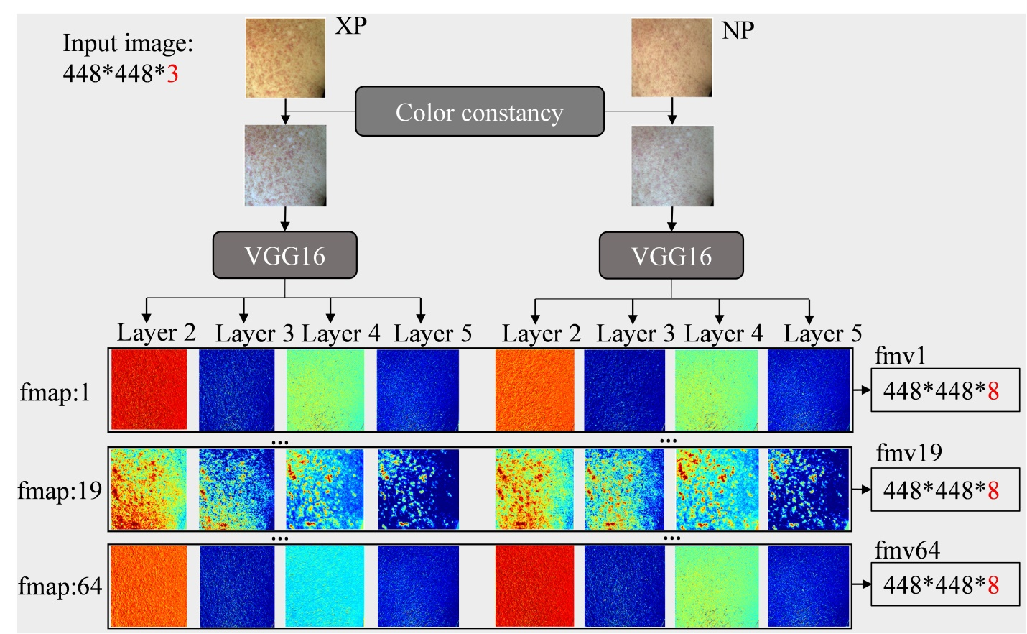
Figure S1 Image pre-processing and feature extraction. Each layer outputs 64 feature maps (fmap). Features are combined across layers into length eight vectors, resulting in 64 feature map vectors (fmv). 1, 19, and 64 are used as examples. The color scale for each feature map is [0, 0.7]. fmap: feature map; fmv: feature map vector
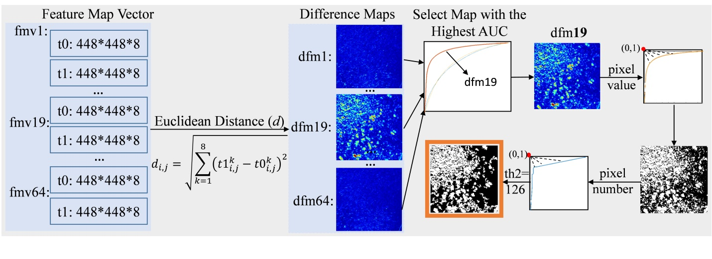
Figure S2 Selection of optimal difference map and thresholds on left chest (LC) t0–t1. First, 64 maps of feature vectors (fmv) were obtained by VGG16, from which Euclidean distances are calculated for difference maps. The optimal difference map (dfm19) was selected by the highest AUC of the ROC curve. Second, threshold based on pixel value was selected for dfm19 (threshold 1: 0.087) to acquire difference segmentation map. After connected areas labeling on difference segmentation map, a threshold based on the number of connected pixels was selected (threshold 2: 126) to acquire the final change detection map. dfm: difference maps; i,j: pixel positions
Dice calculation
- Dice index = (2|X ⋂ Y|)/(|X| + |Y|), where |X| is the number of pixels annotated by a human, |Y| is the number of pixels yielded by the algorithm, and |X ⋂ Y| is the number of pixels selected by both.

