Supplementary information
Supplementary Figure S1. Newly reported new daily cases shows the number of cases reported every 24 hours.

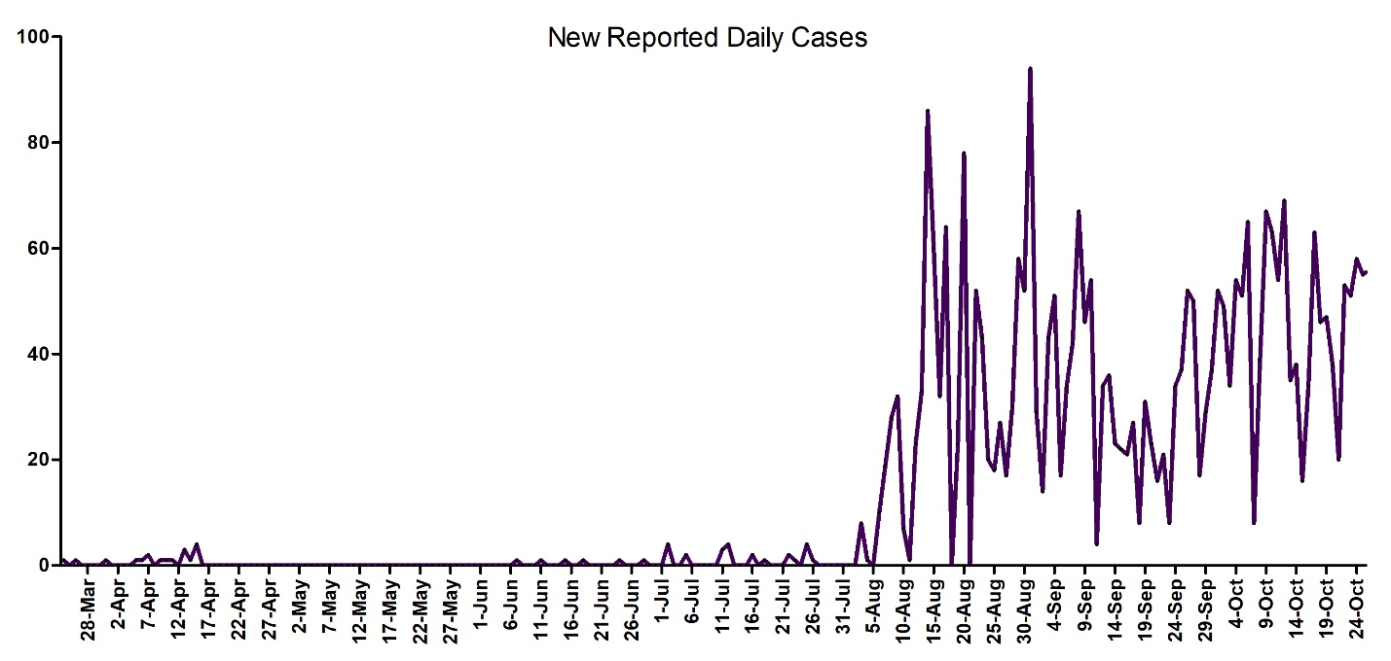
Supplementary Figure S2. Adjusted daily cases shows the number of severe acute respiratory syndrome coronavirus 2-related deaths multiplied by the mortality rate minus the recovered cases. A downward trend is demonstrated by a decrease in daily deaths and an increase in recovered cases until baseline levels are achieved.
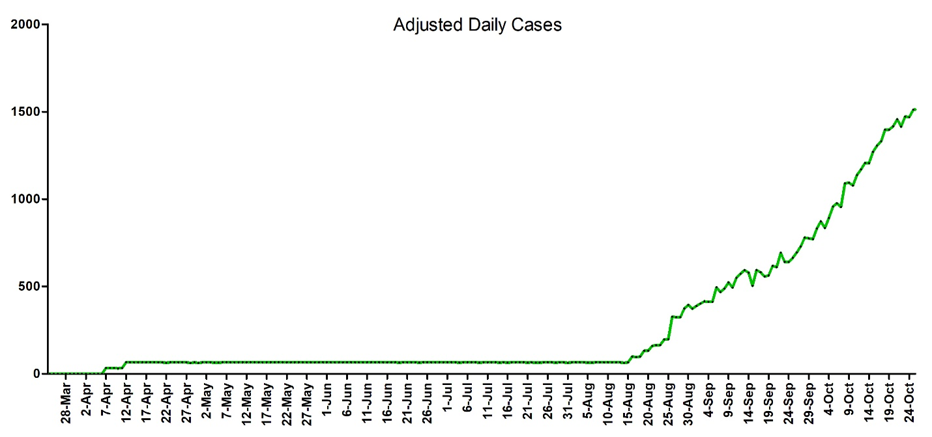

Supplementary Figure S3. Active cases (ACs) and undetected cases (UCs). ACs represent the difference between cumulative reported cases (CRepCs) and cumulative recovered cases (CRecCs). A downward trend is demonstrated by a decrease in CRepCs and an increase in CRecCs.
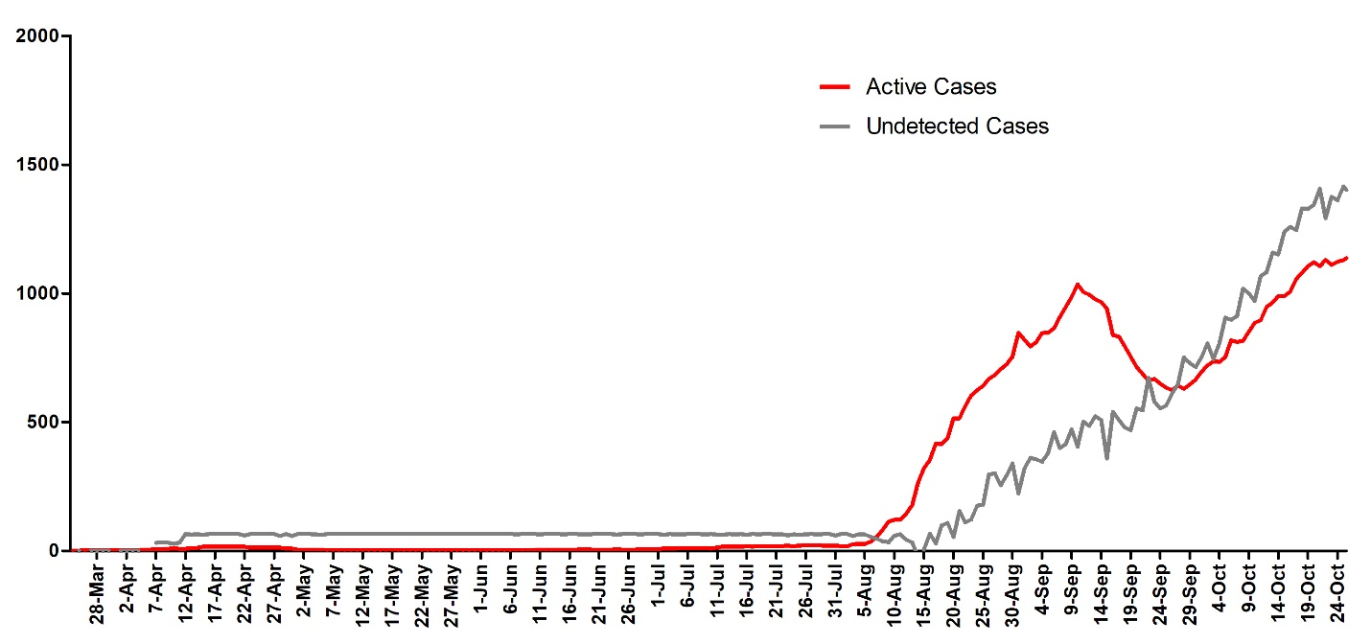

Supplementary Figure S4. Cumulative reported cases, cumulative adjusted cases, and adjusted daily cases.
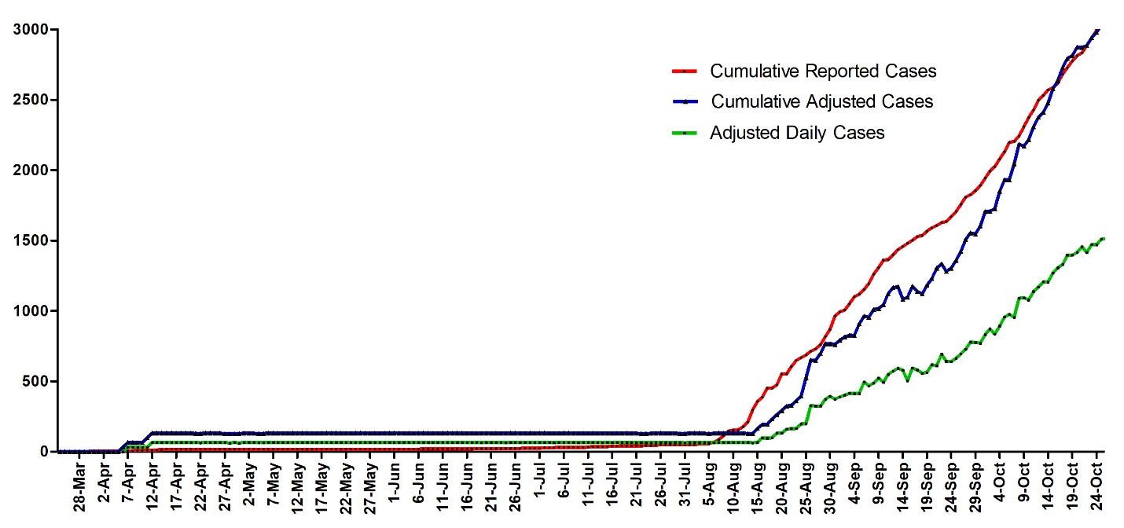

Supplementary Table S1. Starting and end points of first and second COVID-19 waves for 18 countries with robust healthcare testing and reporting.
COVID-19 First Wave |  |  |  | COVID-19 Second Wave
Region | Length₁ | Start | End | Length₂ | Start | End
Florida | 92 | 13-Jun-20 | 13-Sep-20 | 143 | 9-Oct-20 | 1-Mar-21
New York | 80 | 15-Mar-20 | 3-Jun-20 | - | 29-Oct-20 | -
Italy | 86 | 28-Feb-20 | 24-May-20 | 89 | 1-Oct-20 | 29-Dec-20
UK | 86 | 16-Mar-20 | 10-Jun-20 | 152 | 2-Oct-20 | 3-Mar-21
Spain | 56 | 8-Mar-20 | 3-May-20 | 65 | 5-Aug-20 | 9-Dec-20
Japan | 55 | 25-Mar-20 | 19-May-20 | 81 | 6-Jul-20 | 25-Sep-21
Iran | 64 | 28-Feb-20 | 2-May-20 | 116 | 03-Sep-20 | 28-Dec-21
Switzerland | 57 | 10-Mar-20 | 6-May-20 | 146 | 2-Oct-20 | 25-Feb-21
France | 63 | 8-Mar-20 | 10-May-20 | 104 | 20-Aug-20 | 2-Dec-21
Netherlands | 73 | 8-Mar-20 | 20-May-20 | 91 | 1-Sep-20 | 1-Dec-20
Greece | 83 | 16-Jun-20 | 7-Sep-20 | 96 | 18-Oct-20 | 22-Jan-21
Turkey | 82 | 18-Mar-20 | 8-Jun-20 | 102 | 14-Nov-20 | 24-Jan-21
Australia | 75 | 5-Jul-20 | 18-Sep-20 | 102 | 20-Jun-20 | 30-Sep-20
South Africa | 105 | 25-May-20 | 7-Sep-20 | 87 | 15-Nov-20 | 10-Feb-21
Nigeria | 146 | 20-Apr-20 | 13-Sep-20 | 90 | 2-Dec-20 | 2-Mar-21
Egypt | 107 | 19-Apr-20 | 4-Aug-20 | 79 | 18-Nov-20 | 5-Feb-21
Saudi Arabia | 158 | 8-Apr-20 | 13-Sep-20 | - | - | -
Los Angeles | 89 | 15-Jun-20 | 12-Sep-20 | 127 | 26-Oct-20 | 02-Mar-21
Finland | 83 | 14-Mar-20 | 5-Jun-20 | 113 | 08-Sep-20 | 30-Dec-21
Korea | 24 | 20-Feb-20 | 15-Mar-20 | 74 | 09-Nov-20 | 22-Jan-21
Days | 83 |  |  | 108 |  | Days
The COVID-19 wave was estimated at 96 days. Wave length was defined as the arithmetic mean of the number of days between the start of a wave and baseline.

Supplementary Table S2. Length, peak and trough of the first and second COVID-19 waves for 18 countries with robust healthcare testing and reporting.

COVID-19 First Wave |  |  |  |  |  | COVID-19 Second Wave
Region | Length₁ | Peak₁ | Trough₁ | Baseline | Peak Ratio | Length₂ | Peak₂ | Trough₂
Florida | 92 | 10328 | 1415 | 14% | 1.7 | 143 | 17991 | 5426
New York | 80 | 10765 | 598 | 6% | - | - | - | -
Italy | 86 | 5909 | 163 | 3% | 5.8 | 89 | 33977 | 8581
UK | 86 | 5065 | 516 | 10% | 13.4 | 152 | 68053 | 6573
Spain | 56 | 7719 | 332 | 4% | 5.8 | 65 | 44440 | 7955
Japan | 55 | 558 | 30 | 5% | 10.9 | 81 | 6081 | 1149
Iran | 64 | 2875 | 802 | 28% | 4.8 | 116 | 13881 | 6108
Switzerland | 57 | 1122 | 36 | 3% | 9.0 | 146 | 10098 | 518
France | 63 | 5233 | 492 | 9% | 16.6 | 104 | 86852 | 3466
Netherlands | 73 | 1174 | 133 | 11% | 9.5 | 91 | 11119 | 4045
Greece | 83 | 60 | 2 | 3% | 53.8 | 96 | 3227 | 605
Turkey | 82 | 3783 | 922 | 24% | 8.4 | 102 | 31712 | 5642
Australia | 75 | 348 | 7 | 2% | 2.1 | 102 | 715 | 13
South Africa | 105 | 13449 | 903 | 7% | 1.1 | 87 | 15046 | 566
Nigeria | 146 | 626 | 151 | 24% | 2.3 | 90 | 1430 | 711
Egypt | 107 | 1774 | 141 | 8% | 0.8 | 79 | 1407 | 540
Saudi Arabia | 158 | 4301 | 230 | 5% | - | - | - | -
Los Angeles | 89 | 10231 | 2860 | 28% | 4.2 | 127 | 43255 | 4403
Finland | 83 | 164 | 6 | 4% | - | 113 | - | -
Korea | 24 | 435 | 14 | 3% | 2.6 | 74 | 1132 | 354
 | 83 | 4295.95 | 487.65 | 10% | 9.0 | 108 | 22966 | 3333
Wave length was defined as the arithmetic mean of the number of days between the start of a wave and baseline. Peak was the highest number of daily confirmed cases. Trough was the lowest number of daily confirmed cases preceeding a peak. Baseline (Peak₁ : Trough₁) was when the 7-day mean of daily confirmed cases remained at ≤10% of the peak value. The peak ratio was defined as the ratio of the peak of the first wave to the peak of the second wave (Peak₁ : Peak₂). COVID-19 wave was estimated at an average of 96 days (3 months) with a baseline of 98 days (3 months).

Supplementary Figure S5. Mathematical functions that model the number of deaths, Deaths(t), and New Reported Daily Cases, NRDC(t) over time, from the start of the pandemic until March 9, 2021. Evaluating the first derivative of Deaths(t) divided by first derivative of New Reported Daily Cases, NRDC(t) with count at any point along time(t) will yield the mortality rate at time(t) (Equation 1.)

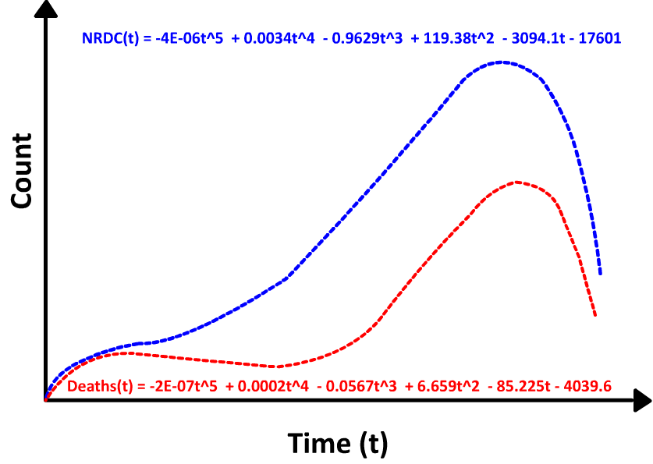
$MR=\left[\frac{\frac{d}{dt}Deaths(t)}{\frac{d}{dt}NRDC(t)}\right]*100$ Equation 1.

$$MR=\left[\frac{\frac{d}{dt} (-2E-07t^{5} + 0.0002t^{4} - 0.0567t^{3} + 6.659t^{2} - 85.225t - 4039.6)}{\frac{d}{dt}(-4E-06t^{5} + 0.0034t^{4} - 0.9629t^{3} + 119.38t^{2} - 3094.1t - 17601)}\right]*100$$

$$MR=\left[\frac{-0.000001t^{4}+0.0008t^{3}-0.1701t^{2}+13.318t-85.225}{-0.00002t^{4}+0.0136t^{3}-2.8887t^{2}+238}\right]*100$$

