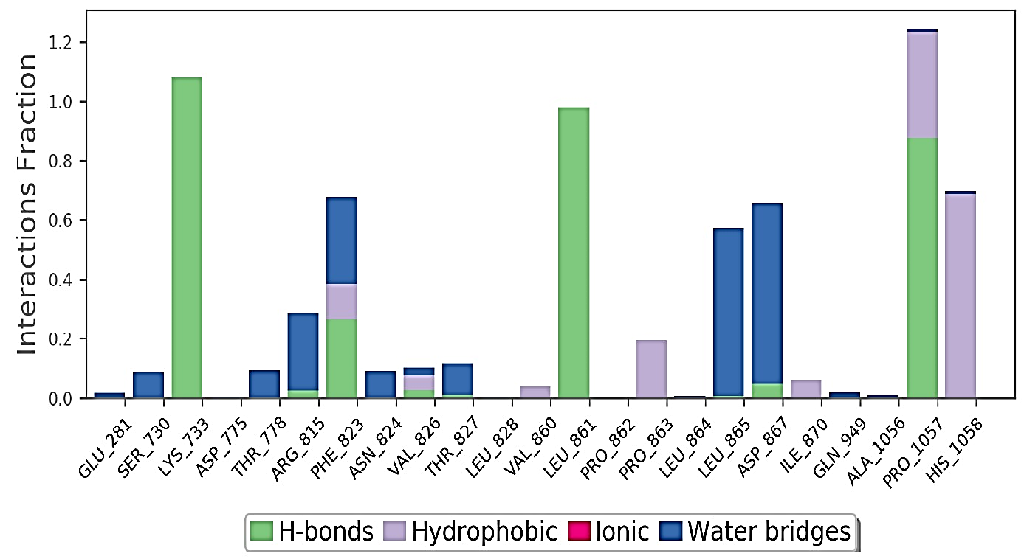
A
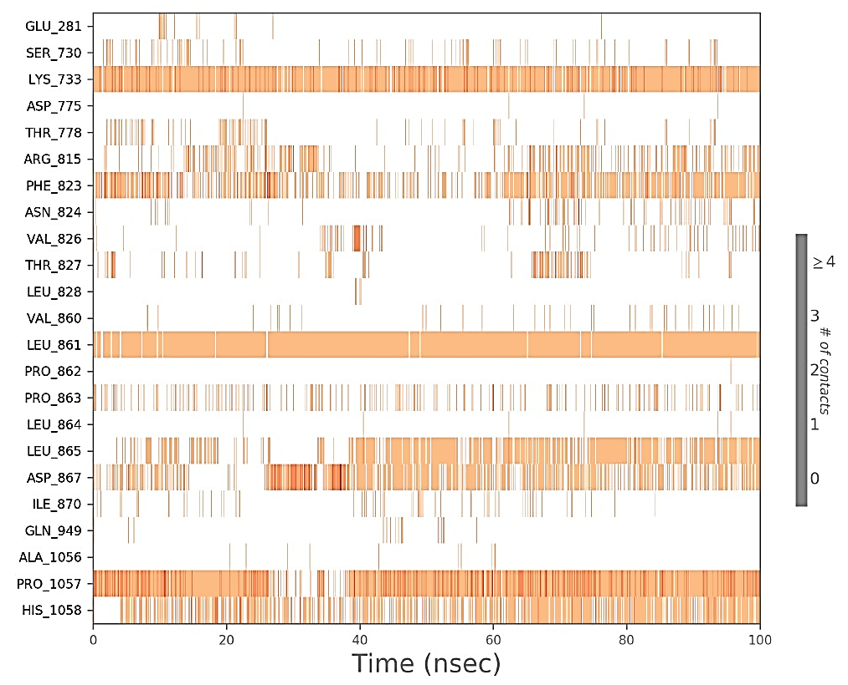
B

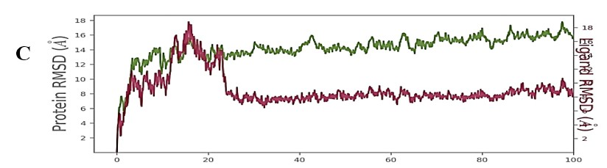
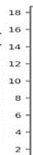

Ligand RMSA (Å)

Supplementary Figure 4. The interactions of amino acid residues of spike protein (S2) with ligand LAS 51389346. (A) The percentages of bonding interaction of amino acid residues between spike protein and ligand. (B) Interaction of LAS 51389346 with residues in each trajectory box. The darker the orange colour, the higher the interaction. (C) The RMSD of superimposed spike protein (72CL) green colour aligned with the ligand LAS 51389346 Red colour.

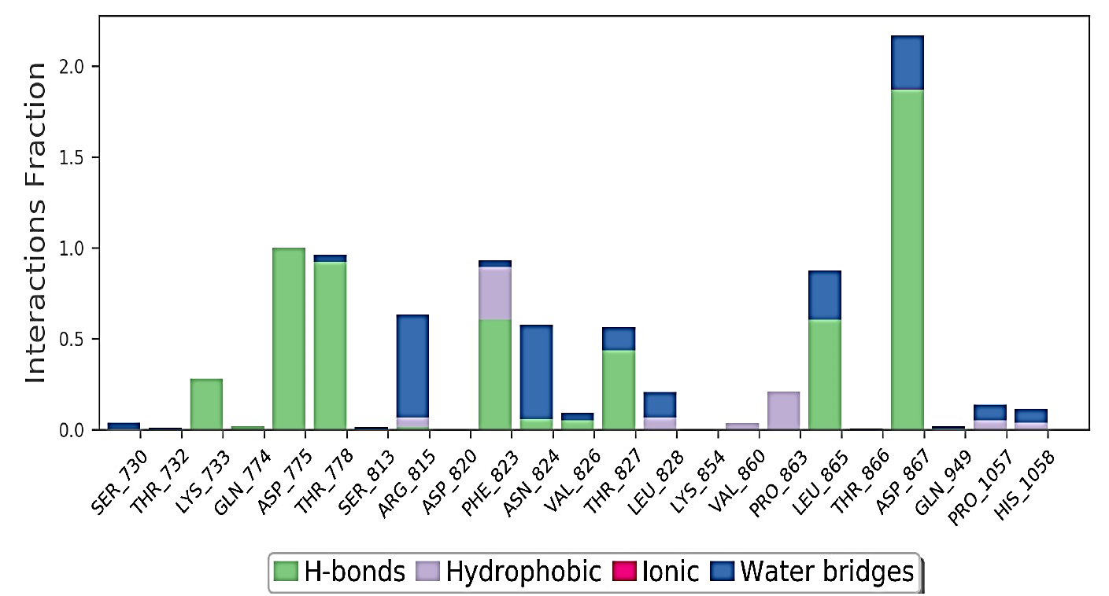
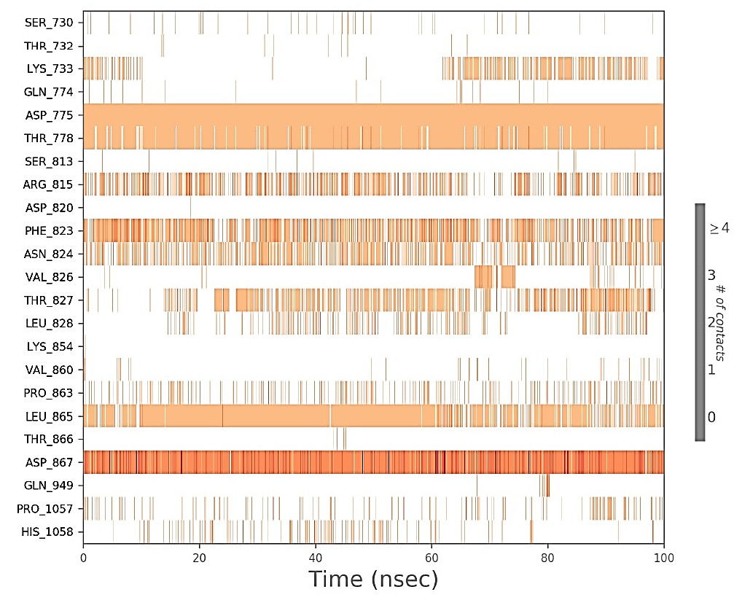
A
B
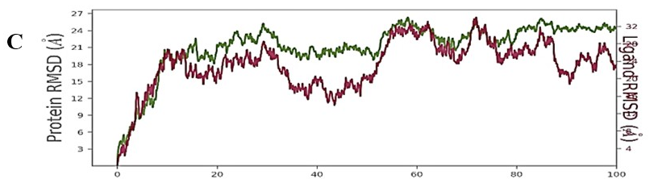
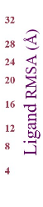

Supplementary Figure 6. The interactions of amino acid residues of spike protein (S2) with ligand BDH 33920970. (A) The percentages of bonding interaction of amino acid residues between spike protein and ligand. (B) Interaction of BDH 33920970 with residues in each trajectory box. The darker the orange colour, the higher the interaction. (C) The RMSD of superimposed spike protein (72CL) green colour aligned with the ligand BDH 33920970 Red colour.

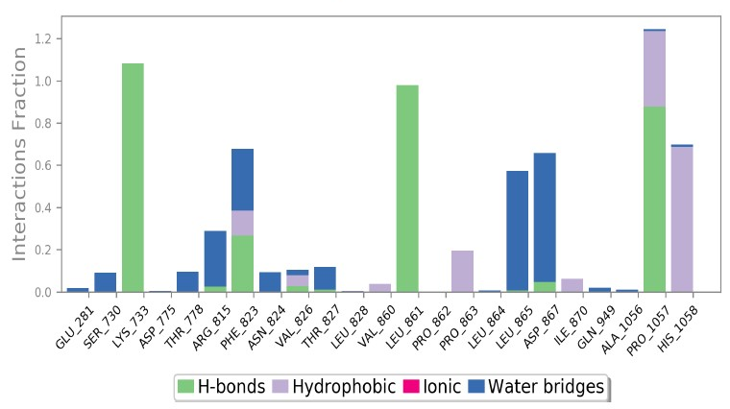
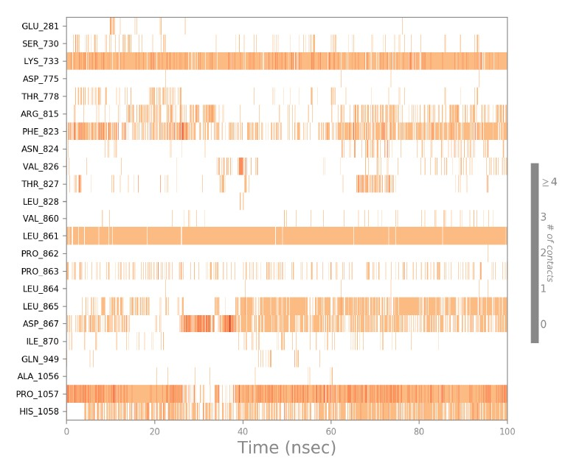
A
B
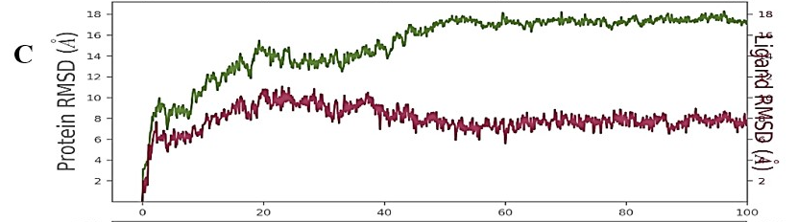
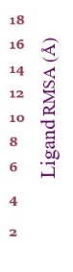

Supplementary Figure 8. The interactions of amino acid residues of spike protein (S2) with ligand LAS 51389268. (A) The percentages of bonding interaction of amino acid residues between spike protein and ligand. (B) Interaction of LAS 51389268 with residues in each trajectory box. The darker the orange colour, the higher the interaction. (C) The RMSD of superimposed spike protein (72CL) green colour aligned with the ligand LAS 51389268 Red colour.

