Appendix B
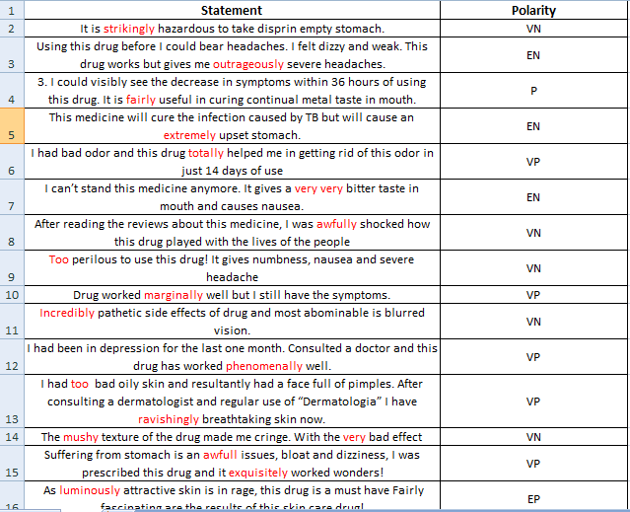
Sample Data Set of Reviews
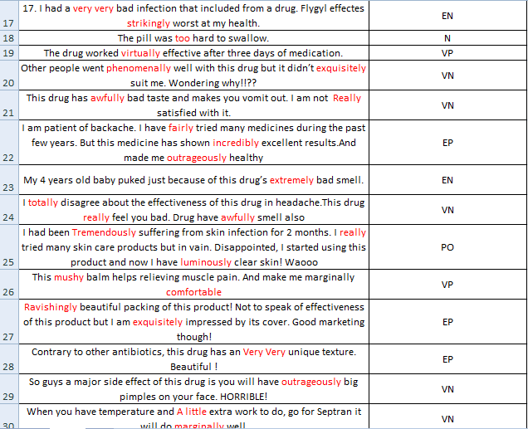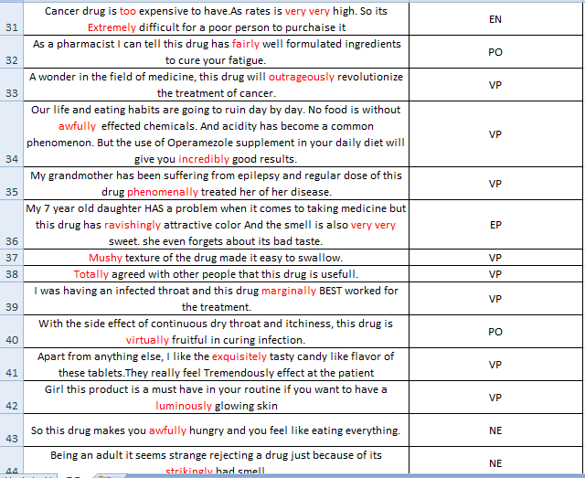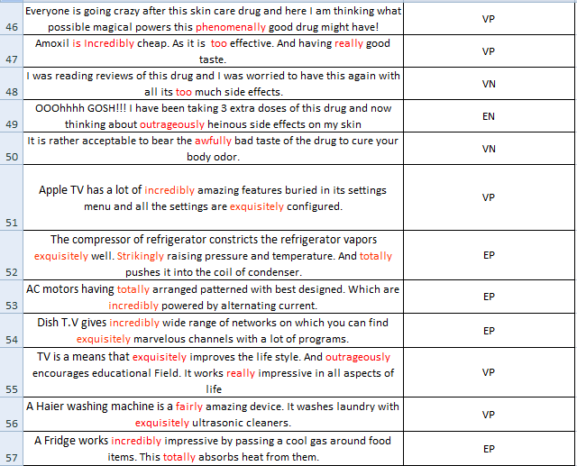

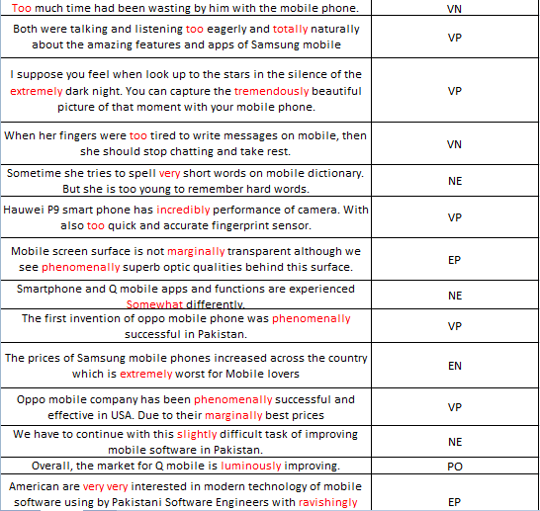

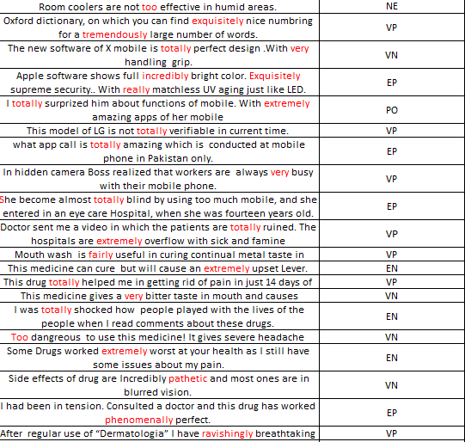

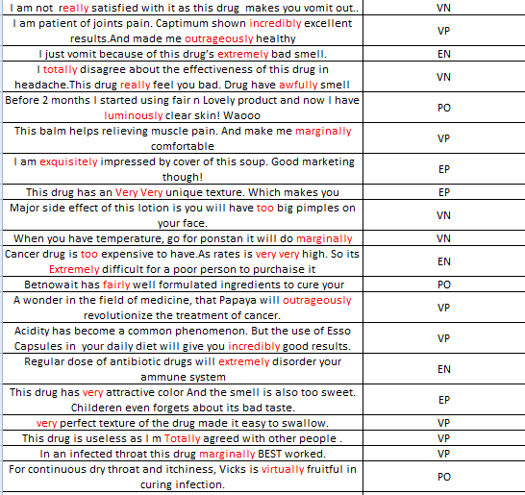

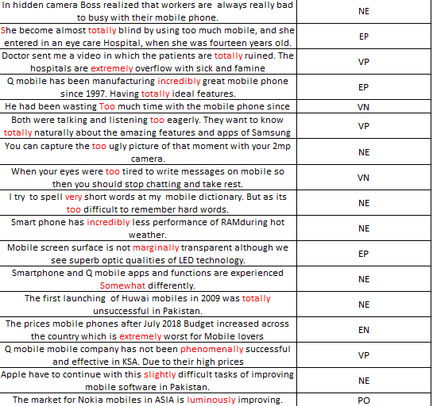

Appendix C
Implemented Reviews from D1
Suffering from pain in stomach is an awfully issues, bloat and dizziness, I was prescribed this drug and it exquisitely good worked wonders! | pain in stomach is an awfully issues |  | issues | awfully |  | 0.00781
 | it exquisitely good worked wonders | Good |  | exquisitely |  | 0.5694
- Pain in stomach is an awful issues
Value = 1− (1− SentiScore) ^{x}
SWN score of issue = 0.00781
Awfully = x = 2.3
1 – (1-0.00781)^{2.3} = 0.01787
Since the word has a negative polarity so we will multiply it with -1
Total value = 0.01787 x -1 = - 0.01787
- It exquisitely good worked wonders
Value = 1− (1− SentiScore) ^{x}
SWN score of Good = 0.5694
exquisitely = x = 2.8
1 – (1-0.5694)^{2.8} = 0.9055
Calculate the value of all statements and calculate the average using
B_{avg} = $\frac{Statement 1 + Statement 2 }{Total Statments}$
B_{avg} = $\frac{-0.00177 + 0.9055 }{2}$ = -0.4519
Now we will have to calculate “B_{n}”
The value of “B_{n}” calculated using falls in the range [−1, 1]. We further normalize this value using min-max normalization to map it to the range [0, 1]. Upon applying min-max normalization to “B_{n}” we get the normalized fuzzy bias value
B_{n} = $\frac{Bavg+1}{2}$
$\frac{0.4519+1}{2}$ = 0.7259
Review is “Very Positive”

This drug has awfully bad taste and makes you vomit out. I am not Really satisfied with it. | drug has awfully bad taste |  | bad | awfully |  | 0.625
 | I am not Really satisfied with it. | satisfied |  | Really | Not | 0.1875

- Drug has awfully bad taste
Value = 1− (1− SentiScore) ^{x}
SWN score of bad = 0.625
Awfully= x = 2.3
1 – (1-0.625)^{2.3} = 0.8952
Since the word has a negative polarity so we will multiply it with -1
Total value = 0.8952 x -1 = - 0.8952
- I am not really satisfied with it.
Value = 1− (1− SentiScore) ^{x}
SWN score of satisfied = 0.3334
Really = x = 2
1 – (1-0.1875)² = 0.3398
Since the word has a Negation so we will multiply it with -1
Total value = 0.3398 x -1 = - 0.3398
Calculate the value of all statements and calculate the average using
B_{avg} = $\frac{Statement 1 + Statement 2 }{Total Statments}$

B_{avg} = $\frac{-0.8952 +(- 0.3398) }{2}$ = -0.6175
Now we will have to calculate “B_{n}”
The value of “B_{n}” calculated using falls in the range [−1, 1]. We further normalize this value using min-max normalization to map it to the range [0, 1]. Upon applying min-max normalization to “B_{n}” we get the normalized fuzzy bias value
B_{n} = $\frac{Bavg+1}{2}$
$\frac{-0.6175+1}{2}$ = 0.1912
Review is “Very Negative”

 | I am not totally agreed about the effectiveness of this drug in headache. This drug really feels you bad. Drug have awfully smell also | I am not totally agreed | agree |  | totally | not | 0.2678
 |  | This drug really feel you bad |  | bad | really |  | 0.625
 |  | Drug have awfully smell also |  | smell | awfully |  | 0.1125
- I am not totally agreed
Value = 1− (1− SentiScore) ^{x}
SWN score of Agree = 0.2678
Totally = x = 4.5
1 – (1-0.2678)^{4.5} = 0.7540
As we have Negation is this sentence so multiply this value with -1
0.7540 x -1 = -0.7540
- This drug really feel you bad
Value = 1− (1− SentiScore) ^{x}
SWN score of Bad = 0.625
Really = x = 2
1 – (1-0.625)² ⁼ 0.8593
Since the word has a negative polarity so we will multiply it with -1
Total value = 0.8593 x -1 = - 0.8593
- Drug have awfully smell also
Value = 1− (1− SentiScore) ^{x}
SWN score of Smell = 0.1125
Awfully = x = 2.3
1 – (1-0.1125)^{2.3} = 0.7599
Since the word has a negative polarity so we will multiply it with -1 = Total value = 0.7599 x -1 = - 0.7599
Sum up the value of all statements and calculate the average using
B_{avg} = $\frac{Statement 1 + Statement 2 + Statement 3 }{Total Statments}$
B_{avg} = $\frac{-0.7540 +\left(-0.8593\right)+(- 0.7599) }{3}$ = -0.7910
Now we will have to calculate “B_{n}”
The value of “B_{n}” calculated using falls in the range [−1, 1]. We further normalize this value using min-max normalization to map it to the range [0, 1] upon applying min-max normalization to “B_{n}” we get the normalized fuzzy bias value
B_{n} = $\frac{Bavg+1}{2}$
$\frac{-0.7910+1}{2}$ = 0.1044
Review is “Extremely Negative”

Implemented Review from D2
The compressor of refrigerator constricts the refrigerator vapors exquisitely well. Strikingly raising pressure and temperature. And totally pushes it into the coil of condenser. | The refrigerator vapors exquisitely well. | well |  | exquisitely |  | 0.3542
 | Strikingly raising pressure and temperature. | Raising |  | Strikingly |  | 0.0625
 | And totally pushes it into the coil of condenser. |  | Pushes | Totally |  | 0.0667

- The refrigerator vapors exquisitely well.
Value = 1− (1− SentiScore) ^{x}
SWN score of well = 0.3542
Exquisitely = x = 2.8
1 – (1-0.3542)^{2.8} = 0.7061
- Strikingly raising pressure and temperature.
Value = 1− (1− SentiScore) ^{x}
SWN score of Raising = 0.0625
Strikingly = x = 1.5
1 – (1-0.0625)^{1.5} = 0.0923
- And totally pushes it into the coil of condenser.
Value = 1− (1− SentiScore) ^{x}
SWN score of Pushes =0.0667
Totally = x =4.5
1 – (1-0.0667)^{4.5} = 0.2671
Since the word has a negative polarity so we will multiply it with -1
Total value =0.2671 x -1 = - 0.2671
Sum up the value of all statements and calculate the average using
B_{avg} = $\frac{Ans 1 + Ans 2 + Ans 3 }{Total Statments}$
B_{avg} = $\frac{0.7061 + 0.0923 +(- 0.2671) }{3}$ =-0.1771
Now we will have to calculate “B_{n}”
The value of “B_{n}” calculated using falls in the range [−1, 1]. We further normalize this value using min-max normalization to map it to the range [0, 1] upon applying min-max normalization to “B_{n}” we get the normalized fuzzy bias value
B_{n} = $\frac{0.1771 + 1}{2}$
0.5885

Review is “Positive”

She fairly guides me about which power back up features are essential. And how to Choose marginally best washing machine? | She fairly guides me about which power back up features are essential. | Guide |  | fairly |  | 0.0114
 | And how to Choose marginally best washing machine? | best |  | Marginally |  | 0.3056

- She fairly guides me about which power back up features are essential.
Value = 1− (1− SentiScore) ^{x}
SWN score of Guide = 0.0114
Fairly = x =0.8
1 – (1-0.0114)^{0.8} = 0.0092

- And how to choose marginally best washing machine?
Value = 1− (1− SentiScore) ^{x}
SWN score of best = 0.3056
Marginally = x = 1.7
1 – (1-0.3056)^{1.7} = 0.4621

Sum up the value of all statements and calculate the average using
B_{avg} = $\frac{Ans 1 + Ans 2 }{Total Statments}$

B_{avg} = $\frac{0.0092 + 0.4621 }{2}$ = 0.2356

Now we will have to calculate “B_{n}”
The value of “B_{n}” calculated using falls in the range [−1, 1]. We further normalize this value using min-max normalization to map it to the range [0, 1] upon applying min-max normalization to “B_{n}” we get the normalized fuzzy bias value
B_{n} = $\frac{0.2356 +1}{2}$
0.6178
Review is “Positive”

- The right washing machine should have marginally unbeaten features.
The right washing machine should have marginally unbeaten features. It also has function to deliver luminously clean clothes. | The right washing machine should have marginally unbeaten features | Unbeaten |  | marginally |  | 0.125
 | It also has function to deliver luminously clean clothes. | clean |  | luminously |  | 0.246
Value = 1− (1− SentiScore) ^{x}
SWN score of Unbeaten = 0.125
Marginally = x = 1.7
1 – (1-0.125)^{1.7} = 0.2031
- It also has function to deliver luminously clean clothes.
Value = 1− (1− SentiScore) ^{x}
SWN score of clean = 0.246
Luminously = x =2.5
1 – (1-0.246)^{2.5} = 0.5064

Sum up the value of all statements and calculate the average using
B_{avg} = $\frac{Ans 1 + Ans 2 }{Total Statments}$

B_{avg} = $\frac{0.2031 + 0.5064 }{2}$ = 0.3547

Now we will have to calculate “B_{n}”
The value of “B_{n}” calculated using falls in the range [−1, 1]. We further normalize this value using min-max normalization to map it to the range [0, 1] upon applying min-max normalization to “B_{n}” we get the normalized fuzzy bias value
B_{n} = $\frac{0.3547+1}{2}$
0.6773
Review is “Very positive”

Implemented Review from D3
Samsung mobile software shows full incredibly bright color. Exquisitely supreme curve.. With really matchless UV aging just like LED. | full incredibly bright color | bright |  | incredibly |  | 0.2614
 | Exquisitely supreme curve | supreme |  | Exquisitely |  | 0.3125
 | really matchless UV aging | matchless |  | really |  | 0.50

- Full incredibly bright color
Value = 1− (1− SentiScore) ^{x}
SWN score of bright = 0.2614
Incredibly = x = 2.5
1 – (1-0.2614)^{2.5} = 0.5311
- Exquisitely supreme curve
Value = 1− (1− SentiScore) ^{x}
SWN score of supreme = 0.3125
Exquisitely = x = 2.8
1 – (1-0.3125)^{2.8 =} 0.649
- Really matchless UV aging
Value = 1− (1− SentiScore) ^{x}
SWN score of matchless = 0.50
really = x = 2
1 – (1-0.50)² = 0.75
Sum up the value of all statements and calculate the average using
B_{avg} = $\frac{Statement 1 + Statement 2 + Statement 3 }{Total Statments}$

B_{avg} = $\frac{0.5311 +\left(0.649\right)+(0.75) }{3}$ = 0.6433
Now we will have to calculate “B_{n}”
The value of “B_{n}” calculated using falls in the range [−1, 1]. We further normalize this value using min-max normalization to map it to the range [0, 1] upon applying min-max normalization to “B_{n}” we get the normalized fuzzy bias value
B_{n} = $\frac{Bavg+1}{2}$
$\frac{0.6433+1}{2}$ = 0.8216
Review is “Very Positive”

The Pixel 2 is all about two things: taking exquisitely fantastic photos. And fairly unrivalled Google's software. | taking exquisitely fantastic photos | fantastic |  | exquisitely |  | 0.375
 | And fairly unrivalled Google's software | unrivalled |  | fairly |  | 0.5
- Taking exquisitely fantastic photos
Value = 1− (1− SentiScore) ^{x}
SWN score of fantastic = 0.3375
Exquisitely= x = 2.8
1 – (1-0.3375)^{2.8 =} 0.6842
- And fairly unrivalled Google’s software
Value = 1− (1− SentiScore) ^{x}
SWN score of unrivalled = 0.5
Fairly = x = 0.8
1 – (1-0.5)^{0.8} = 0.4256
Since the word has negative polarity so we will multiply it with -1
0.4256 X -1= -0.4256
Sum up the value of all statements and calculate the average using
B_{avg} = $\frac{Statement 1 + Statement 2 }{Total Statments}$

B_{avg} = $\frac{0.6842+(-0.4256) }{2}$ = 0.1293
Now we will have to calculate “B_{n}”
The value of “B_{n}” calculated using falls in the range [−1, 1]. We further normalize this value using min-max normalization to map it to the range [0, 1] upon applying min-max normalization to “B_{n}” we get the normalized fuzzy bias value
B_{n} = $\frac{Bavg+1}{2}$
$\frac{0.1293+1}{2}$ = 0.5646
Review is “Positive”

India has marginally raised the prices of oppo mobiles.  As OPPO has radical redesign that's nearly all screen includes a tremendously steadfastness cutting-edge having facial recognition feature | India has marginally raised the prices of oppo mobiles |  | raised | marginally |  | 0.0417
 | includes a tremendously steadfastness cutting-edge |  | steadfastness | tremendously |  | 0.375
India has marginally raised the prices of oppo mobiles
Value = 1− (1− SentiScore) ^{x}
SWN score of raised = 0.0417
Marginally= x = 1.7
1 – (1-0.0417)^{1.7 =} 0.0698
Since the word has negative polarity so we will multiply it with -1
0.0698 X -1= -0.0698
- Includes a tremendously steadfastness cutting edge
Value = 1− (1− SentiScore) ^{x}
SWN score of steadfastness = 0.375
tremendously = x = 3
1 – (1-0.375)³= 0.755
Since the word has negative polarity so we will multiply it with -1
0.755 X -1= -0.755
Sum up the value of all statements and calculate the average using
B_{avg} = $\frac{Statement 1 + Statement 2 }{Total Statments}$

B_{avg} = $\frac{-0.0698+(-0.755) }{2}$ = -0.4124
Now we will have to calculate “B_{n}”
The value of “B_{n}” calculated using falls in the range [−1, 1]. We further normalize this value using min-max normalization to map it to the range [0, 1] upon applying min-max normalization to “B_{n}” we get the normalized fuzzy bias value
B_{n} = $\frac{Bavg+1}{2}$
$\frac{0.4124+1}{2}$ = 0.2938
Review is “Very Negative”

 | Laptop technology strikingly getting better day by day. There are mushy features available on modern models. | Laptop technology strikingly getting better day by day. | better |  | strikingly |  | 0.4904
 |  | There are mushy features available on modern models. | Features |  | mushy |  | 0.0469
- Laptop technology strikingly getting better day by day.
Value = 1− (1− SentiScore) ^{x}
SWN score of better = 0.4904
Strikingly = x = 1.5
1 – (1-0.4904)^{1.5} = 0.6363
- There are mushy features available on modern models.
Value = 1− (1− SentiScore) ^{x}
SWN score of Features = 0.0469
Mushy = x = 3
1 – (1-0.0469)³ = 0.1343

Sum up the value of all statements and calculate the average using
B_{avg} = $\frac{Ans 1 + Ans 2 }{Total Statments}$

B_{avg} = $\frac{0.6363 + 0.1343 + }{3}$ = 0.3853

Now we will have to calculate “B_{n}”
The value of “B_{n}” calculated using falls in the range [−1, 1]. We further normalize this value using min-max normalization to map it to the range [0, 1] upon applying min-max normalization to “B_{n}” we get the normalized fuzzy bias value
B_{n} = $\frac{0.3853 +1}{2}$
0.6926
Review is “Very positive”

 | A Haier washing machine is a fairly amazing device. It washes laundry with exquisitely ultrasonic cleaners. | Machine is a fairly amazing device. | amazing |  | awfully |  | 0.6875
 |  | It washes laundry with exquisitely ultrasonic cleaners | Ultrasonic |  | exquisitely |  | 0.375
- Machine is a fairly amazing device.
Value = 1− (1− SentiScore) ^{x}
SWN score of amazing = 0.6875
Awfully = x = 2.3
1 – (1-0.6875)^{2.3} = 0.9312

- It washes laundry with exquisitely ultrasonic cleaners.
Value = 1− (1− SentiScore) ^{x}
SWN score of Ultrasonic = 0.375
Exquisitely = x = 2.8
1 – (1-0.375)^{2.8} = 0.7318

Sum up the value of all statements and calculate the average using
B_{avg} = $\frac{Ans 1 + Ans 2 }{Total Statments}$

B_{avg} = $\frac{0.9312+ 0.7318 }{2}$ = 0.8315

Now we will have to calculate “B_{n}”
The value of “B_{n}” calculated using falls in the range [−1, 1]. We further normalize this value using min-max normalization to map it to the range [0, 1] upon applying min-max normalization to “B_{n}” we get the normalized fuzzy bias value
B_{n} = $\frac{0.8315+1}{2}$
0.9157

Review is “Extremely positive”

