Supplementary information to

COVID-19: The Second Wave is not due to Cooling-down in Autumn
Walter Langel

1) Method
Each outbreak N is fitted by a single logistic function, as described earlier in [1]:
$I_{N}\left(t\right)=\frac{S_{N}}{1+\left(\frac{S_{N}}{I_{0,N}}-1\right)∙exp\left({-t}/{τ_{N}}\right)}$ (1)
This well-known expression is the solution of the compartment model SIR [2] (cf. SI 3) below). It is adapted to the observed case numbers and infection rates from very different countries by varying only a few parameters (Table 1):
(1) $S_{N}$ is the maximum number of infected persons at infinite time in a given outbreak, i.e. the whole group, which is in reach of the initially infected $I_{0,N}$. In the simplest case, $S_{N}$ is as high as the total population P of the respective country (cf. [3]). Physical distancing limits the total number of individuals, which may be attained by the initially infected group. Thus, in the modified SIR-model, $S_{N}$ in each outbreak is much smaller than P, and
$x_{N}=S_{N}/P≪1$.
(2) $I_{0,N}≪S_{N}$ is the number of individuals triggering a new outbreak N.
(3) The time constant $τ_{N}$ of usually a few days has two implications:
- During the first days an exponential increase of both case number and infection rate is seen, and the often cited doubling time is related to $τ_{N}$ by $τ_{2,N}=τ_{N}∙ln\left(2\right)$.
- Later, increase is significantly slower than exponential and the case number and infection rate asymptotically attain a constant value $S_{N}$ and zero, respectively. The time scale of the outbreak is also determined by $τ_{N}$.
(4) The second order rate constant $k_{2,N}$ of the SIR model (cf. $λ$ in [2]) is given as $k_{2,N}=\frac{1}{τ_{N}∙S_{N}}$ (in days⁻¹·susceptible persons⁻¹). It characterizes the transmissivity of infected persons. In a recent paper [4], reference is made to two studies agreeing that only 17-20% of the infected cases remain asymptomatic, still being contagious, but less than the symptomatic individuals. This infectivity of asymptomatic cases indeed is one reason for the rapid spreading of the SARS-CoV-2 virus. Another recent study from dec., 18th 2020 quotes a quantitative result saying that the transmission due to asymptomatic cases is smaller by a factor of 3.85 than by symptomatic ones [5] .

An attempt was made to split the SIR equations into those for persons with a strong and with a weak immune system [6]. The parameters for these equations (equations 1 in [6]) for both groups were in fact very similar. In the present work, k₂ is an average over the two groups, which were not distinguished. This means that the infectivity of a typical sample of 100 cases containing 20 asymptomatic ones is slightly lower than that of 100 only symptomatic cases by factor 0.85: $y=\frac{80+20/3.85}{100}=0.85$. In the model presented here, this means that k_{2,n} is reduced by about a factor of 1.2 with respect to a fully contagious group, which correction is smaller than the statistic error to be expected from data analysis.

In variance to earlier work [2] [6], several distinct outbreaks of the virus are assigned to the observed data and each outbreak N is described independently by a new logistic function $I_{N}\left(t\right)$. Previously [1], outbreaks were considered separately in single time intervals. A first outbreak, N=0, showed purely exponential increase and was quickly interrupted after a few days. Sufficient data are now available for consistent fits over the whole time from end of January to mid-November. It thus turned out that the further outbreaks N=1-4 do not occur consecutively, but may also overlap on the time scale, and that the case numbers $I_{N}\left(t\right)$ add up to the total case number $\left(t\right)$ :
$I\left(t\right) =\sum_{N=1}^{4}{I_{N}\left(t\right)}=\sum_{i=1}^{4}{\frac{S_{N}}{1+P_{N}∙exp\left({-t}/{τ_{N}}\right)}}$ (2)
$P_{N}=\left(\frac{S_{N}}{I_{N}\left(t_{0,N}\right)}-1\right)∙exp\left({t_{0,N}}/{τ_{N}}\right)$ is used as fit parameter, and the number of infected persons triggering the start of the wave N is estimated as $I_{0,N}=I_{N}\left(t_{0,N}\right)=\frac{S_{N}}{{1+P}_{N} ∙exp\left({{-t}_{0;N}}/{τ_{N}}\right)}$ (3)
(5) The additional parameter $t_{0,N}$ is needed since the outbreaks start at different times. It is determined as the date, when the observed total case number and infection rate significantly increase with respect to the respective calculated sums of the previous waves 1..N-1.

2) Fit of total case numbers
Figure S2.1: Total case numbers as a function of time (incidences per 100,000) are plotted. Dotted black: observed data as given by the John-Hopkins university ( [7]), yellow: extrapolated infection rate before physical distancing (N=0), dark blue: small outbreak after the lock down (N=1), green: outbreak during release N=2), orange: enhanced outbreak in summer/winter (N=3), blue: enhanced second wave in autumn/spring since October (N=4).

3) Interference of case numbers with test frequency
Argentina
South Africa

Figure SI 4.1: Numbers of new cases per 100 000 per week (blue) in comparison with the tests divided by ten (red) for South Africa (top) and Argentina (bottom). Coincidence of the red and the blue curve would mean that exactly 10% of the tests are positive. For South Africa a peak of new infections with incidences of 200 was found in summer from November to January, in spite of the small number of tests.

There is some poor correlation between new infections and cases for both countries (Figure SI 4.1). In practice correlation does not mean, however, that the increase of case numbers is an artefact due to the availability of more tests. In the contrary, the outbreak of more cases, of which a major number is symptomatic (s. SI 1), leads to the application of more tests in the environment of confirmed cases or hotspots, and thus the test frequency just follows the virus spreading. As a consequence, it is correct to consider the case numbers independently of the test frequency.

4) Logistic function with recovery
The logistic function works well as an empirical fit for the observed data (Figure 1, SI 2.1). The function is the exact solution of an SI(R)-model without recovery (“R”) [2], i.e. the transition from a small number of infected I₀ to the infection of all susceptible persons S_{N}. Now it is shown at the example of one eruption in Table 1, (“blue” for Germany) that the logistic function works in good approximation also with a realistic recovery constant. Using the symbols introduced in the main text, the SIR equations [2] read
Days from beginning
$\frac{dS}{dT}=-k_{2}∙S∙I$ (1)
$\frac{dI}{dT}=k_{2}∙S∙I-β∙I$ (2)
$\frac{dR}{dT}=β∙I$ (3)
$S_{N}=S\left(t\right)+I\left(t\right)+R\left(t\right)$ (4)
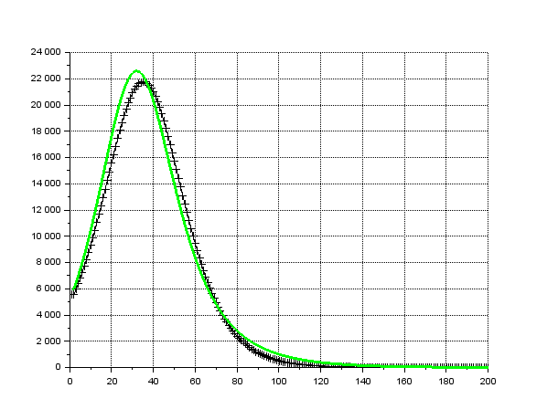
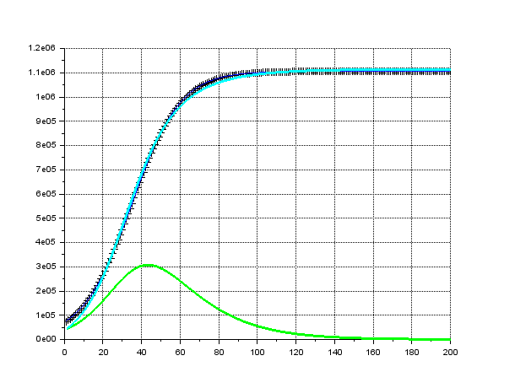
where R and $β$ are the number of recovered persons and the recovery rate in days⁻¹, respectively.
Cases / day
Accumulated cases

Figure S3.1: Results from the numerical integration of equations (1-4) (full lines) in comparison with the logistic function (+) as quoted in Table 1 for the forth eruption in Germany with parameters I(t=0)=I₀=68,000; S_{N}=1,106,000; $k_{2}=7.1∙{10}^{-8}$ (black +). (left) accumulated data, (right) per day. Legend see text.

First it was checked that the logistic function with the given parameters, solves these equations without recovery, β=0. They were numerically integrated yielding curves for (left) I(t) (black line), S_{N}-S(t) (dark blue line), (right) $\frac{∆I}{1 day}$ (black line), which cannot be distinguished from the logarithmic function (Figure S3.1).

Recovery is then included by setting $β=1/\left(17days\right)$ (green lines). This value of $β$ is taken from [8], where data on virus shedding times were compiled and an average time of 17 days is quoted. A similar value was used for the first order recovery constant in [6]. We obtain different curves in the left figure for the accumulated number of cases S_{N}-S(t) (cyan) and for the infected at each moment I(t) (green). Due to an increasing number R(t) of recovered persons, I(t) is smaller than S_{N}-S(t) (cf. eq. (4)) and finally attains zero. The cyan curve for accumulated cases follows again very closely the logistic function. Also, in the right figure, the green curve for $\frac{∆I}{1 day}$ follows closely the logistic function (+). The above parameters had to be modified to I₀=43,000, S_{N}=1,242,000, k₂=11,7·10⁻⁸, however. Now, infected persons I(t) recover after a time and are no further transmitting the virus (cf. green line, left figure). Thus, not all of the susceptible persons are infected before the infected are recovered, $I\left(t\right)→0$, and S_{N} has to be higher than without recovery for still attaining the observed $S_{N}-S\left(t→∞\right)=1,106,000$ accumulated infected cases. The rate constant k₂ also has to be slightly higher than without recovery.

In the manuscript, the logistic functions are maintained without any corrections accounting for recovery, since the infectiveness of infected persons to others does not seem to be fully understood, and the value of β may be ill-defined.

References

1. | Langel W. Extrapolation of infection data for the COVID-19 virus in 21 countries and states and estimate of the efficiency of lock down. medrXiv [Internet].; 2020 . Available from: https://doi.org/10.1101/2020.06.17.20134254.
2. | Amaro JE, Dudouet J, Orce JN. Global analysis of the COVID-19 pandemic using simple epidemiological models. Appl Math Mod. 2021: 995-1008.
3. | List of countries and dependencies by population. wikipedia. [Internet], 2020, . Available from: https://en.wikipedia.org/wiki/List_of_countries_and_dependencies_by_population.
4. | Pollock AM, Lancaster J. Asymptomatic transmission of covid-19: What we know, and what we don’t. BMJ. 2020 (12): m4851.
5. | Sayampanathan AA, Heng CS, Pin PH, Pang J, Leong TY, Lee VJ. Infectivity of asymptomatic versus symptomatic COVID-19. The Lancet. 2021 (1): 93-94.
6. | Ghanbari B. On forecasting the spread of the COVID-19 in Iran: The second wave. Chaos, Solitons & Fractals. 2020: 110176.
7. | GitHub. [Internet], 2021, . Available from: https://github.com/owid/covid-19-data/blob/master/public/data.
8. | Cevik M, Tate M, Lloyd O, Maraolo AE, Schafers J, Ho A. SARS-CoV-2, SARS-CoV, and MERS-CoV viral load dynamics, duration of viral shedding, and infectiousness: a systematic review and meta-analysis. The Lancet. 2021: E13.

