Supplementary Material

Figure S1 Measure of osteoblast prolifaration by flow cytometry analysis. (a) number of S-Phase, G2M and G0G1cell cycle of control; (b) number of S-Phase, G2M and G0G1cell cycle with P-CG-01 treatment.
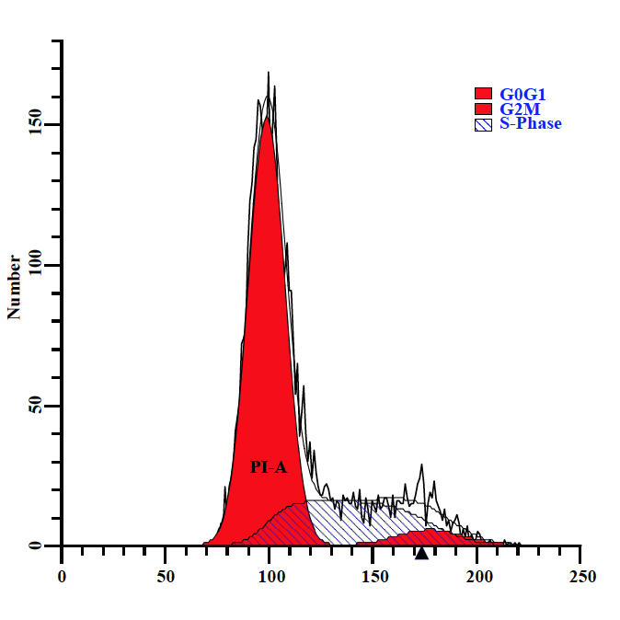
（a）

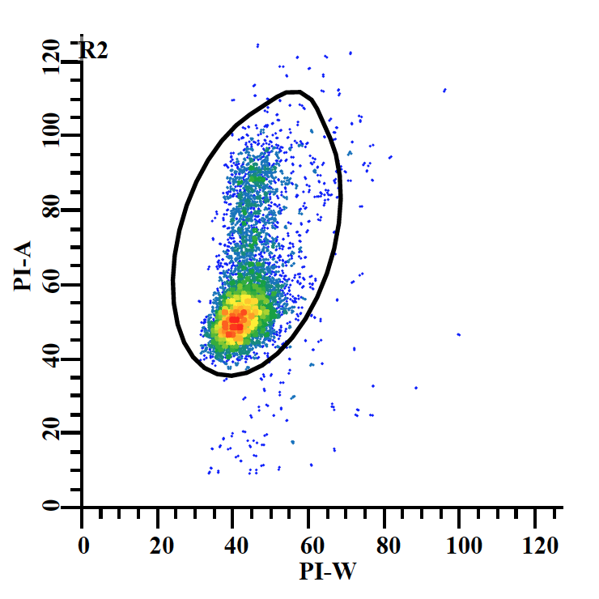
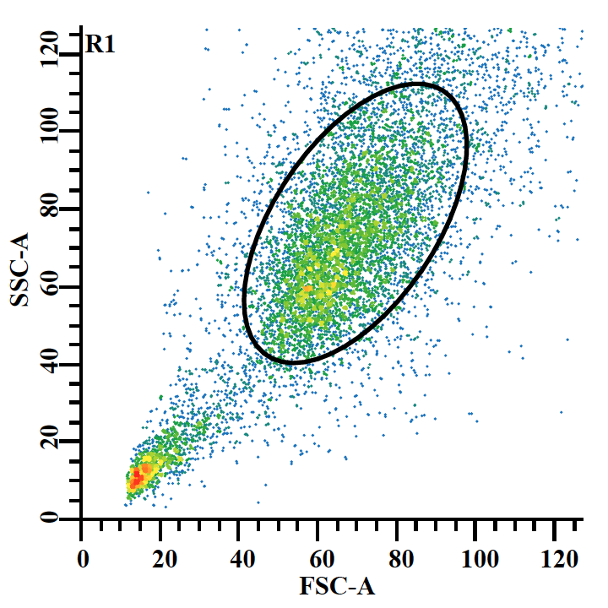

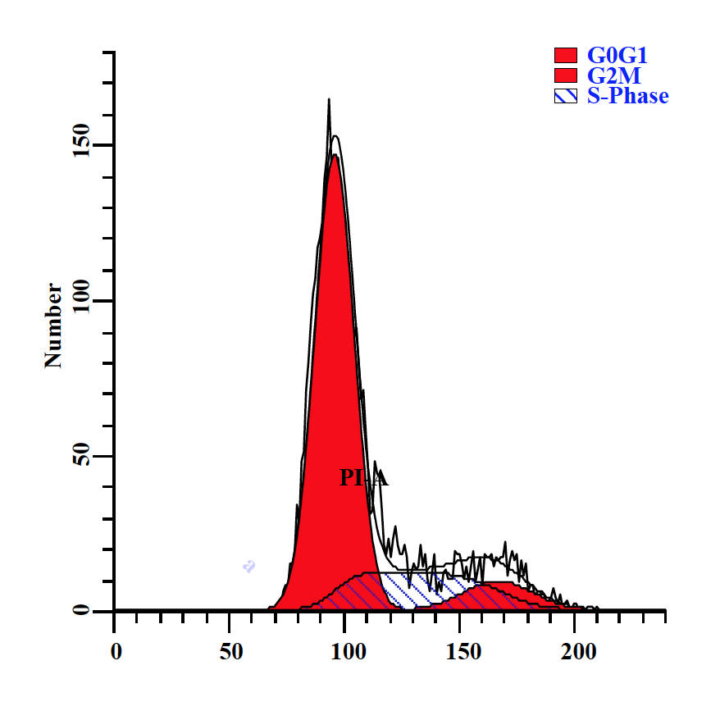
（b）
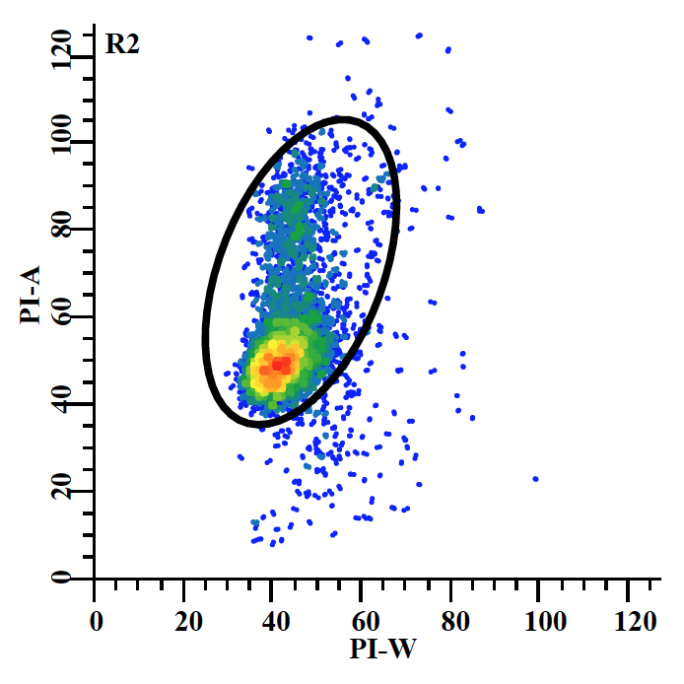
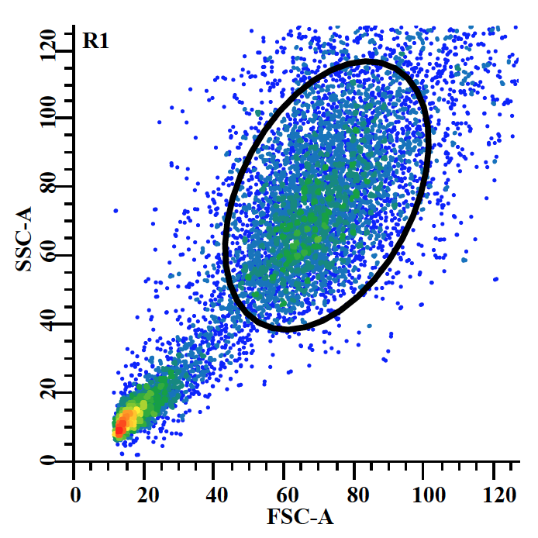

Table S1 Extremum of ALP activity of Caco2
OD405 | 1 | 2 | 3 | 4 | 5 | 6 | Extremum
AL | 0.5474 | 0.5348 | 0.5292 | 0.5883 | 0.4453 | 0.5147 | 3.49±0.43
BP | 0.6055 | 0.4353 | 0.6287 | 0.5116 | 0.5101 | 0.4038 | 3.49±0.43
AL | 0.1794 | 0.1491 | 0.1481 | 0.148 | 0.1905 | 0.1297 | 3.49±0.43
BP | 0.1288 | 0.1048 | 0.2087 | 0.1564 | 0.1716 | 0.1201 | 3.49±0.43
OD405 means that the absorbance was measured at 405 nm
Table S2 Primer sequence related about osteoblast proliferation and differentiation.
Primer Name | Sequence(5'to3')
GAPDH-f | CATGTTCCAGTATGACTCCACTC
GAPDH-r | GGCCTCACCCCATTTGATGT
ERK1-f | GACACCCCTGTCCTTTTGGATCTGGTCCTG
ERK1-r | AAGCAGAGACCCCAGCAAAGTGAGAGAAG
ERK2-f | GGTGCCATGGAACAGGTTGTTCCCAAATGC
ERK2-r | GTATGGGTGGGCCAGAGCCTGTTCAACTTC
p38-f | GAAAGTGTAAAGCCAATTCCAGTGTTGGAC
p38-r | GTCTGCCTCCTTCTGGGCTCCAAATGATTC
ALP-f | CGCTATCCTGGCTCCGTGCT
ALP-r | GTGGGCTGGCAGTGGTCAGA
RUNX2-f | TCAGGCATGTCCCTCGGTAT
RUNX2-r | TGGCAGGTAGGTATGGTAGTG
BMP2-f | ACCATGGTGGCCGGGACCCGCTG
BMP2-r | ACGACACCCGCAGCCCTCCACAAC
OCN-f | CTGACCTCACAGATCCCAAGC
OCN-r | TGGTCTGATAGCTCGTCACAAG
OPN-f | CCAACGGCCGAGGTGATA
OPN-r | CAGGCTGGCTTTGGAACTTG

