Supporting Information
Dendrobine Suppresses Lipopolysaccharide-induced Gut Inflammation in a Co-culture of Intestinal Epithelial Caco-2 Cells and RAW264.7 Macrophages
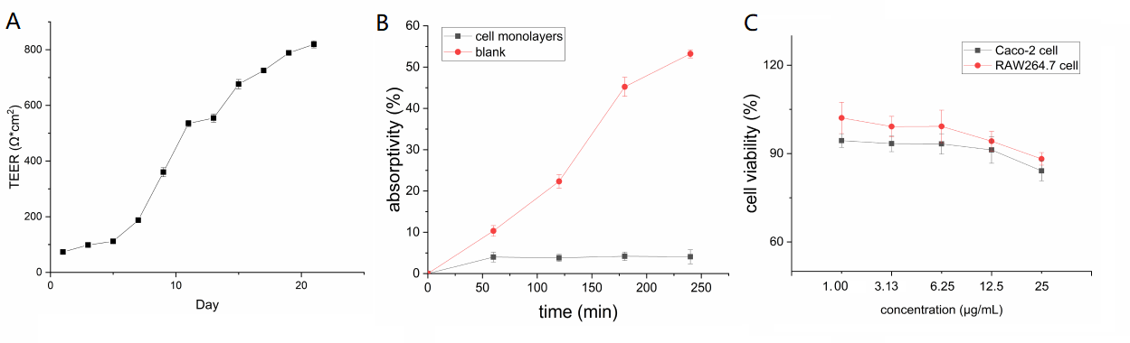Figure S1 Caco-2 monolayer culture. (A) TEER of Caco-2 monolayers was >800 Ω·cm². (B) Sodium fluorescein absorptivity. (C) Cell viability.

